Additional Information about Equipment

Shown below are the various equipment types we are able to use on air shipments, ranked from the least expensive and least insulation, to the most expensive with the most insulation.

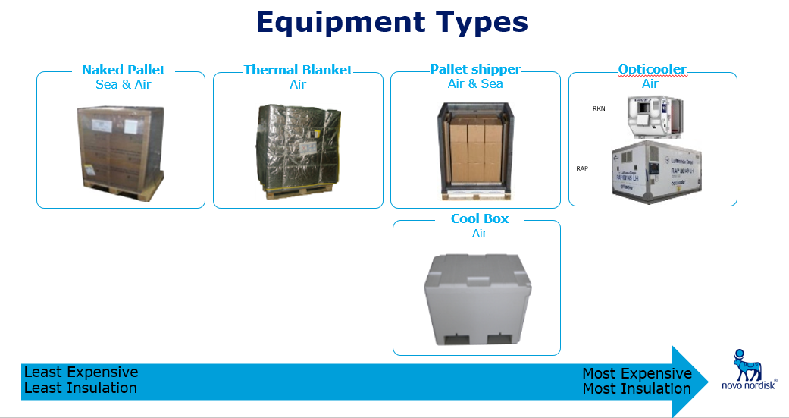

Before it goes into the equipment, shipments are packed as such:

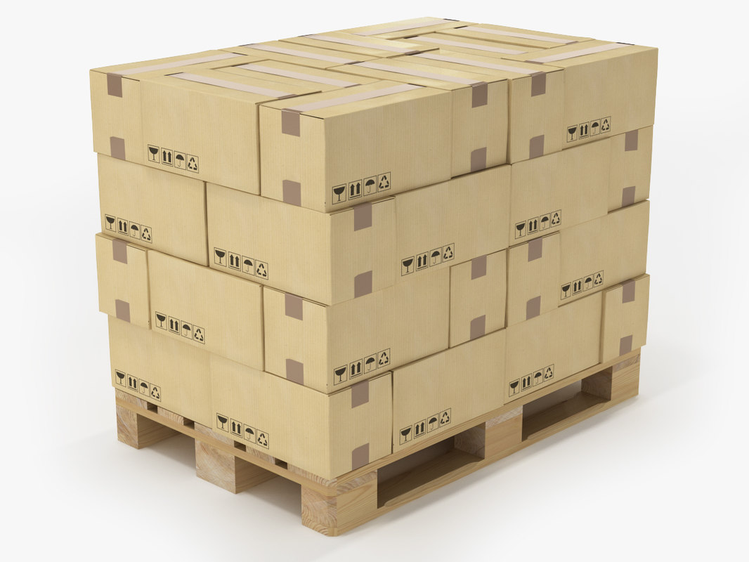

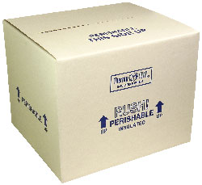

Pallet

Shipper Boxes

(each box gets a temp logger)

Special information about pallet shippers and cool boxes:

These two equipment types do the same thing. We use the pallet shipper to hold 8-20 shipper boxes. A cool box can hold only one shipper box. Examples: A shipment with 30 shipper boxes will have 2 pallet shippers. A shipment with 22 shipper boxes will have 1 pallet shipper and 2 cool boxes.

In the data, the equipment is normally listed together as shipper box/cool box.

Sometimes in the data, equipment is also listed as Naked Pallet/Thermal Blanket. The equipment is currently chosen based on the product inside, and the shipments that list either mean the shipment could go with either one, and the equipment is chosen based on other products in the shipment (if there are any). We are not certain which type has been chosen, it is never recorded what equipment was actually used, we gather our data based on what the rule is. For these shipment, you can assume thermal blanket was normally chosen